Round Island Lighthouse Preservation Society
2023 Proposed Operations Budget
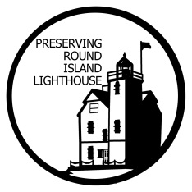

Administrative Fees $300
Non-Food Trip Expenses $800
Proposed Work Projects $3000
Miscellaneous $500

